Report on Intercounties 10k held in conjunction with Brighton 10k
on Sunday 20 November 20

The Hertfordshire team/s for this event comprised:
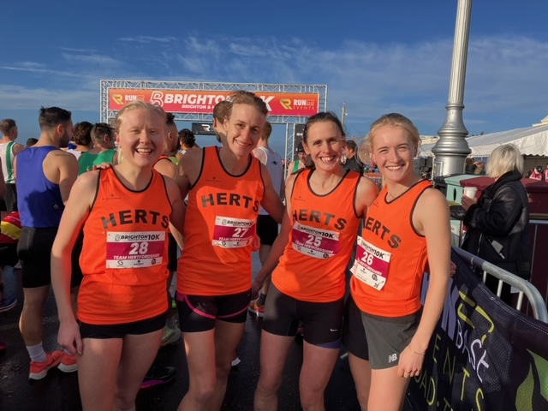

Women
Heather Hann (St Albans Striders)
Katie Harbon (North Herts Road Runners)
Helen Mussen (Watford Joggers)
Megan Walker née Wilson (St Albans Striders)
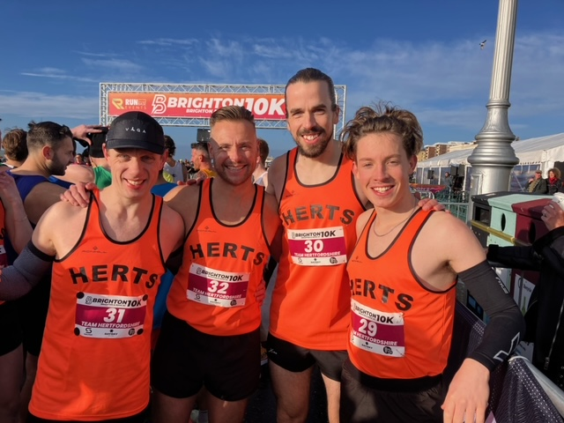

Men
Will Bowran (St Albans Striders)
Matt Cooper (St Albans Striders)
Stefano Federici (St Albans Striders)
Stewart Overton (North Herts Road Runners)

All of the individual team members ran excellently, several achieving PBs.

The women’s team performed exceptionally well coming 2nd and receiving Silver medals for their efforts. Their positions/times were:
Megan Walker 8th in 35:49
Katie Harbon 9th in 36:15
Heather Hann 12th in 36:44
Helen Mussen 17th in 37:29

The men’s team also performed well coming 5th in a very strong field. Their positions/times were:
Will Bowran 19th in 32:42
Stefano Federici 26th in 33:01
Matt Cooper 35th in 33:57
Stewart Overton 49th in 35:00

Overall race results are available on:
https://results.sporthive.com/events/6996060929284046336/races/484049
Team Manager’s Review
Having been in touch post-race with most of the team members, they all enjoyed the experience and were all proud to have represented the County. As stated above, they all ran well, several achieving PBs, which is all that a selector or team manager can expect.
The process of assembling the best possible Hertfordshire team was fairly laborious, mainly due to difficulties communicating with all the clubs, and therefore all the individual athletes in the County. We should consider ways of improving communication. In the event we achieved the optimum team from the athletes who put themselves forward for selection. Attempts to achieve the best possible team were thwarted as two of the team members originally selected had to withdraw, one at a late stage due to injury. Fortunately two other athletes were happy to step in. I also realised at a late stage that I had failed to make contact with one of the leading runners in the County.
I was not able to be present on the day, as I wished to attend the AGM of the National Athletics League. However Megan Walker and Steve Bowran were excellent stand-ins in Brighton.
Regarding the event itself, it is disappointing that it is not supported by more counties.
Richard

